User Stories for Iteration 0

### Feature: Sign up to Study Tracker

As a student  
So that I can use Study Tracker  
I want to create an account and sign in to Study Tracker

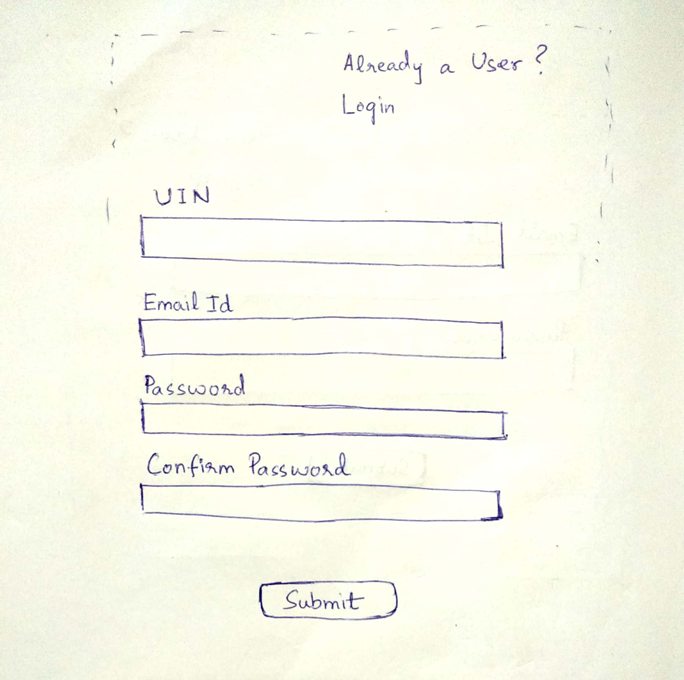

### Feature: Login to Study Tracker

As a registered user of Study Tracker  
So that I can view and edit my study sessions  
I want to login to Study Tracker

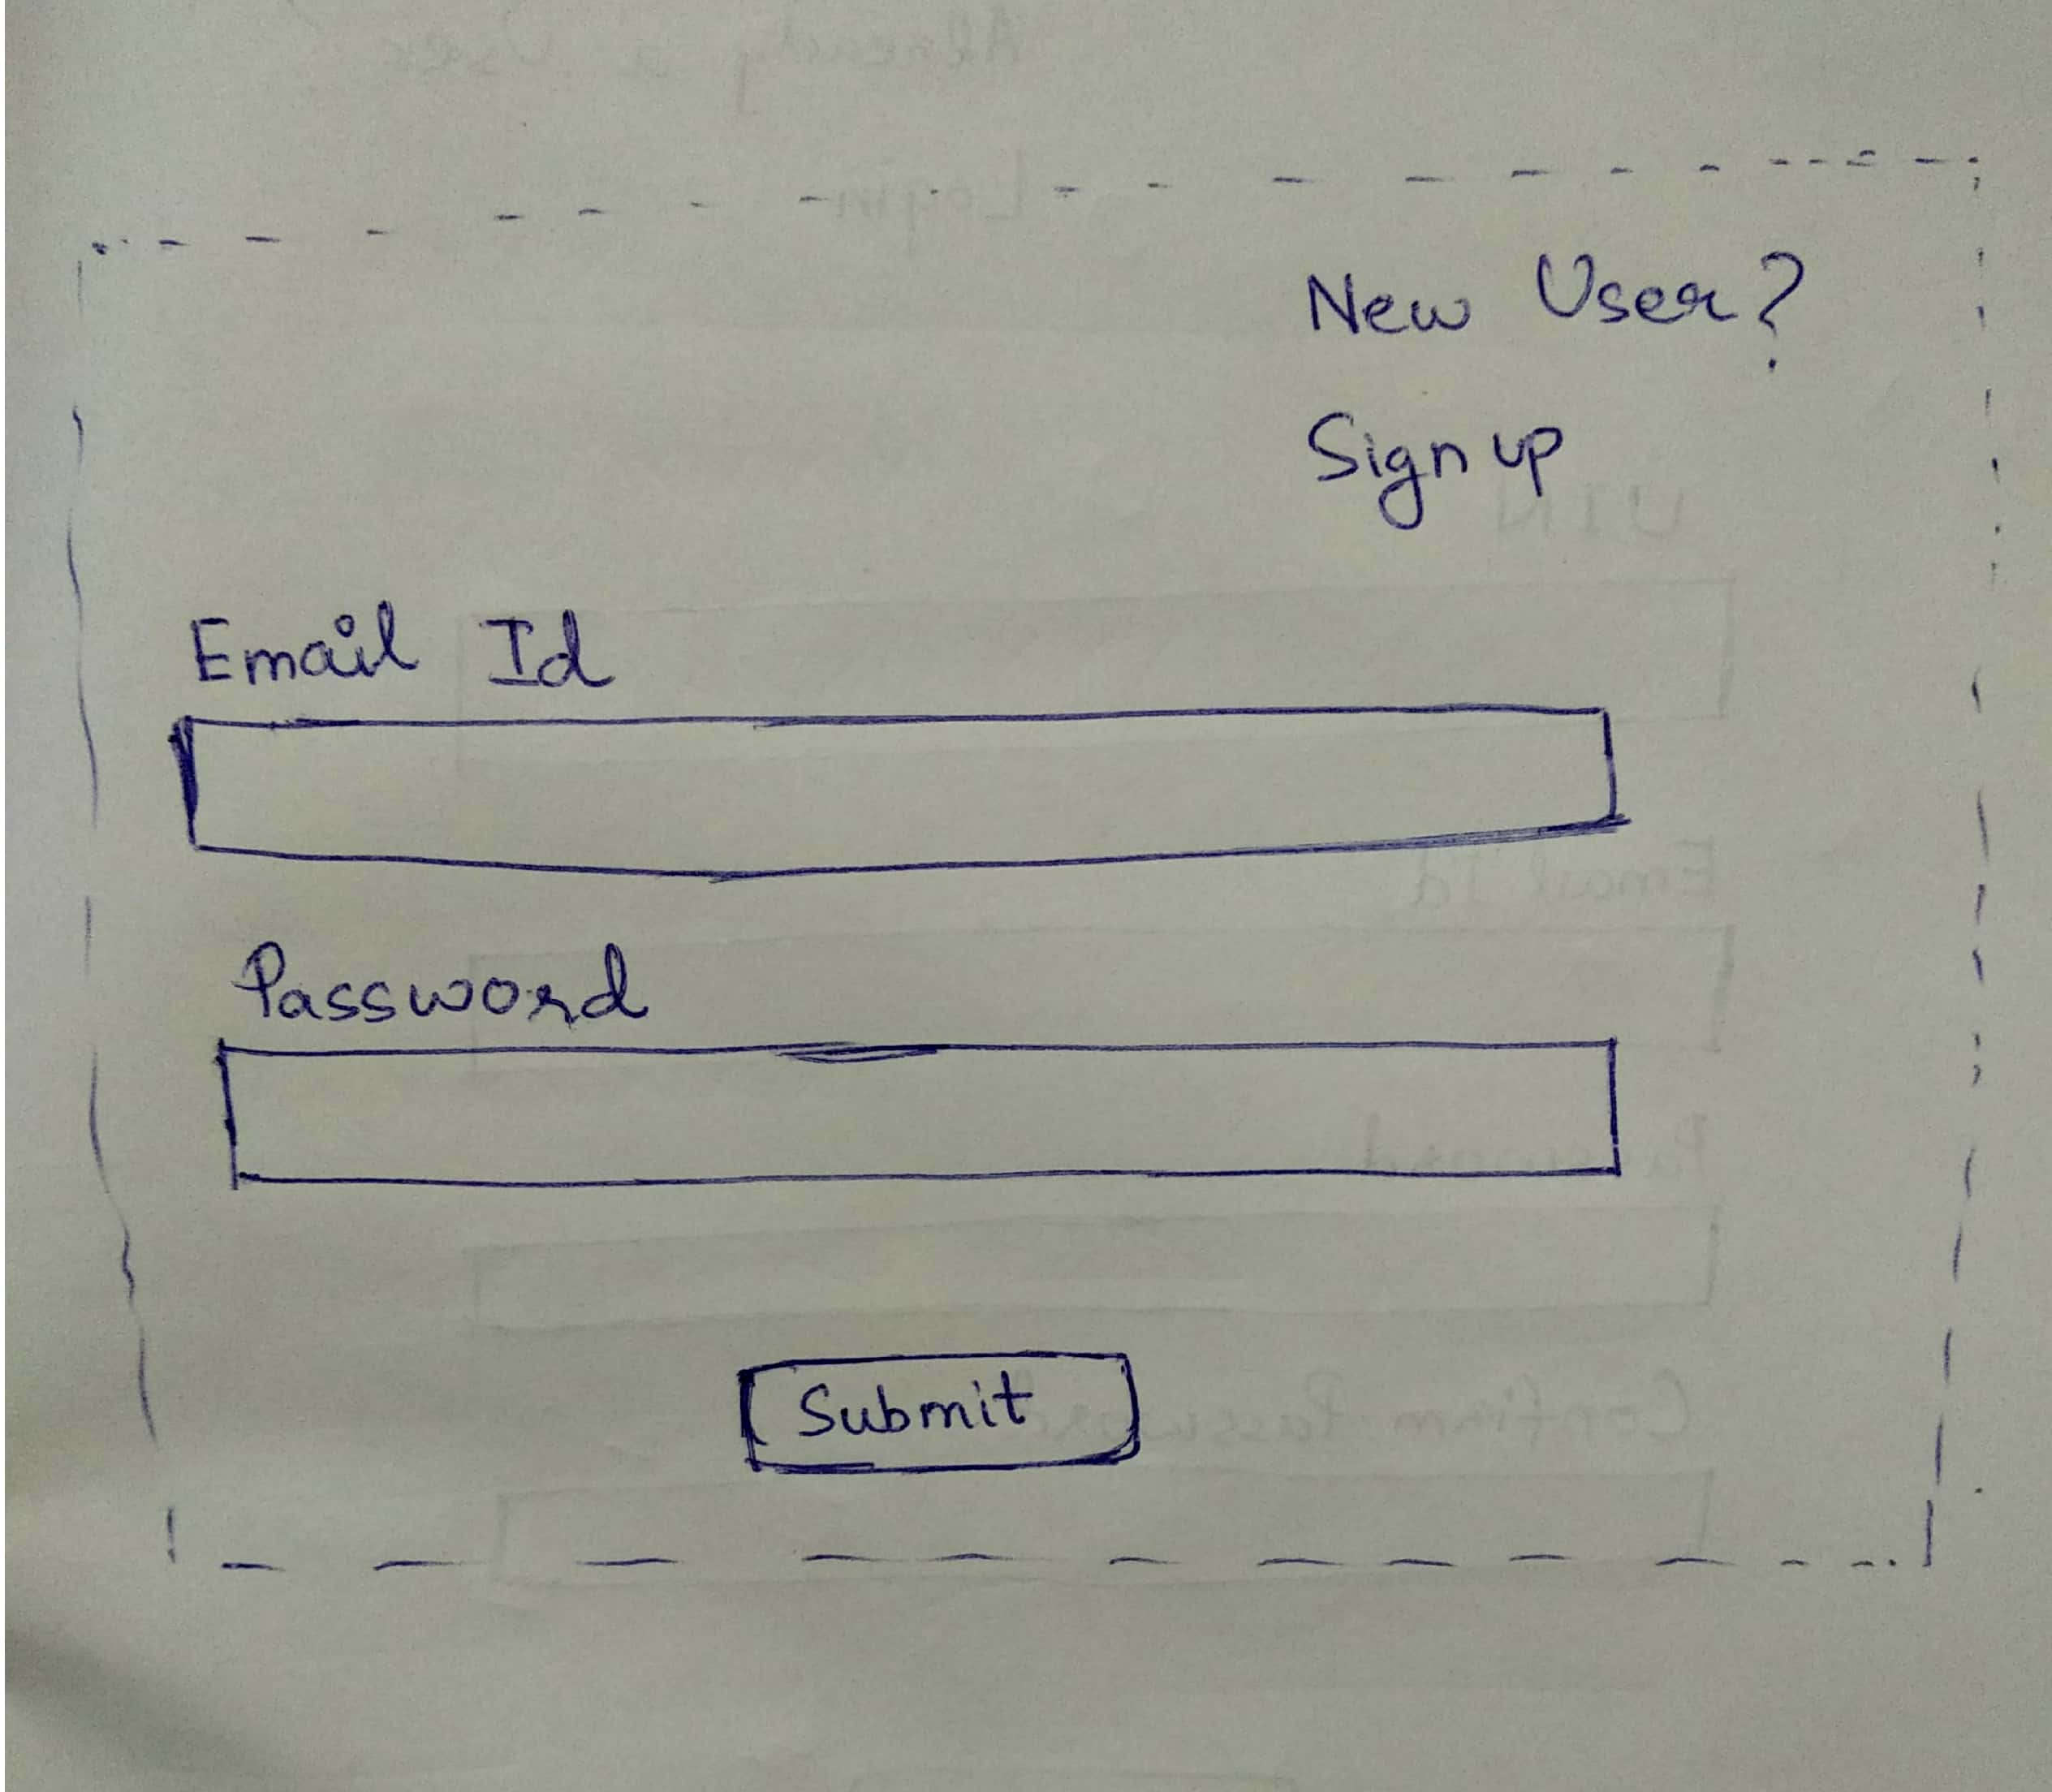

### Feature: Initial Setup Study Tracker

As a user of Study Tracker  
So that I can set up my study sessions  
I want to add details of my subjects and study sessions

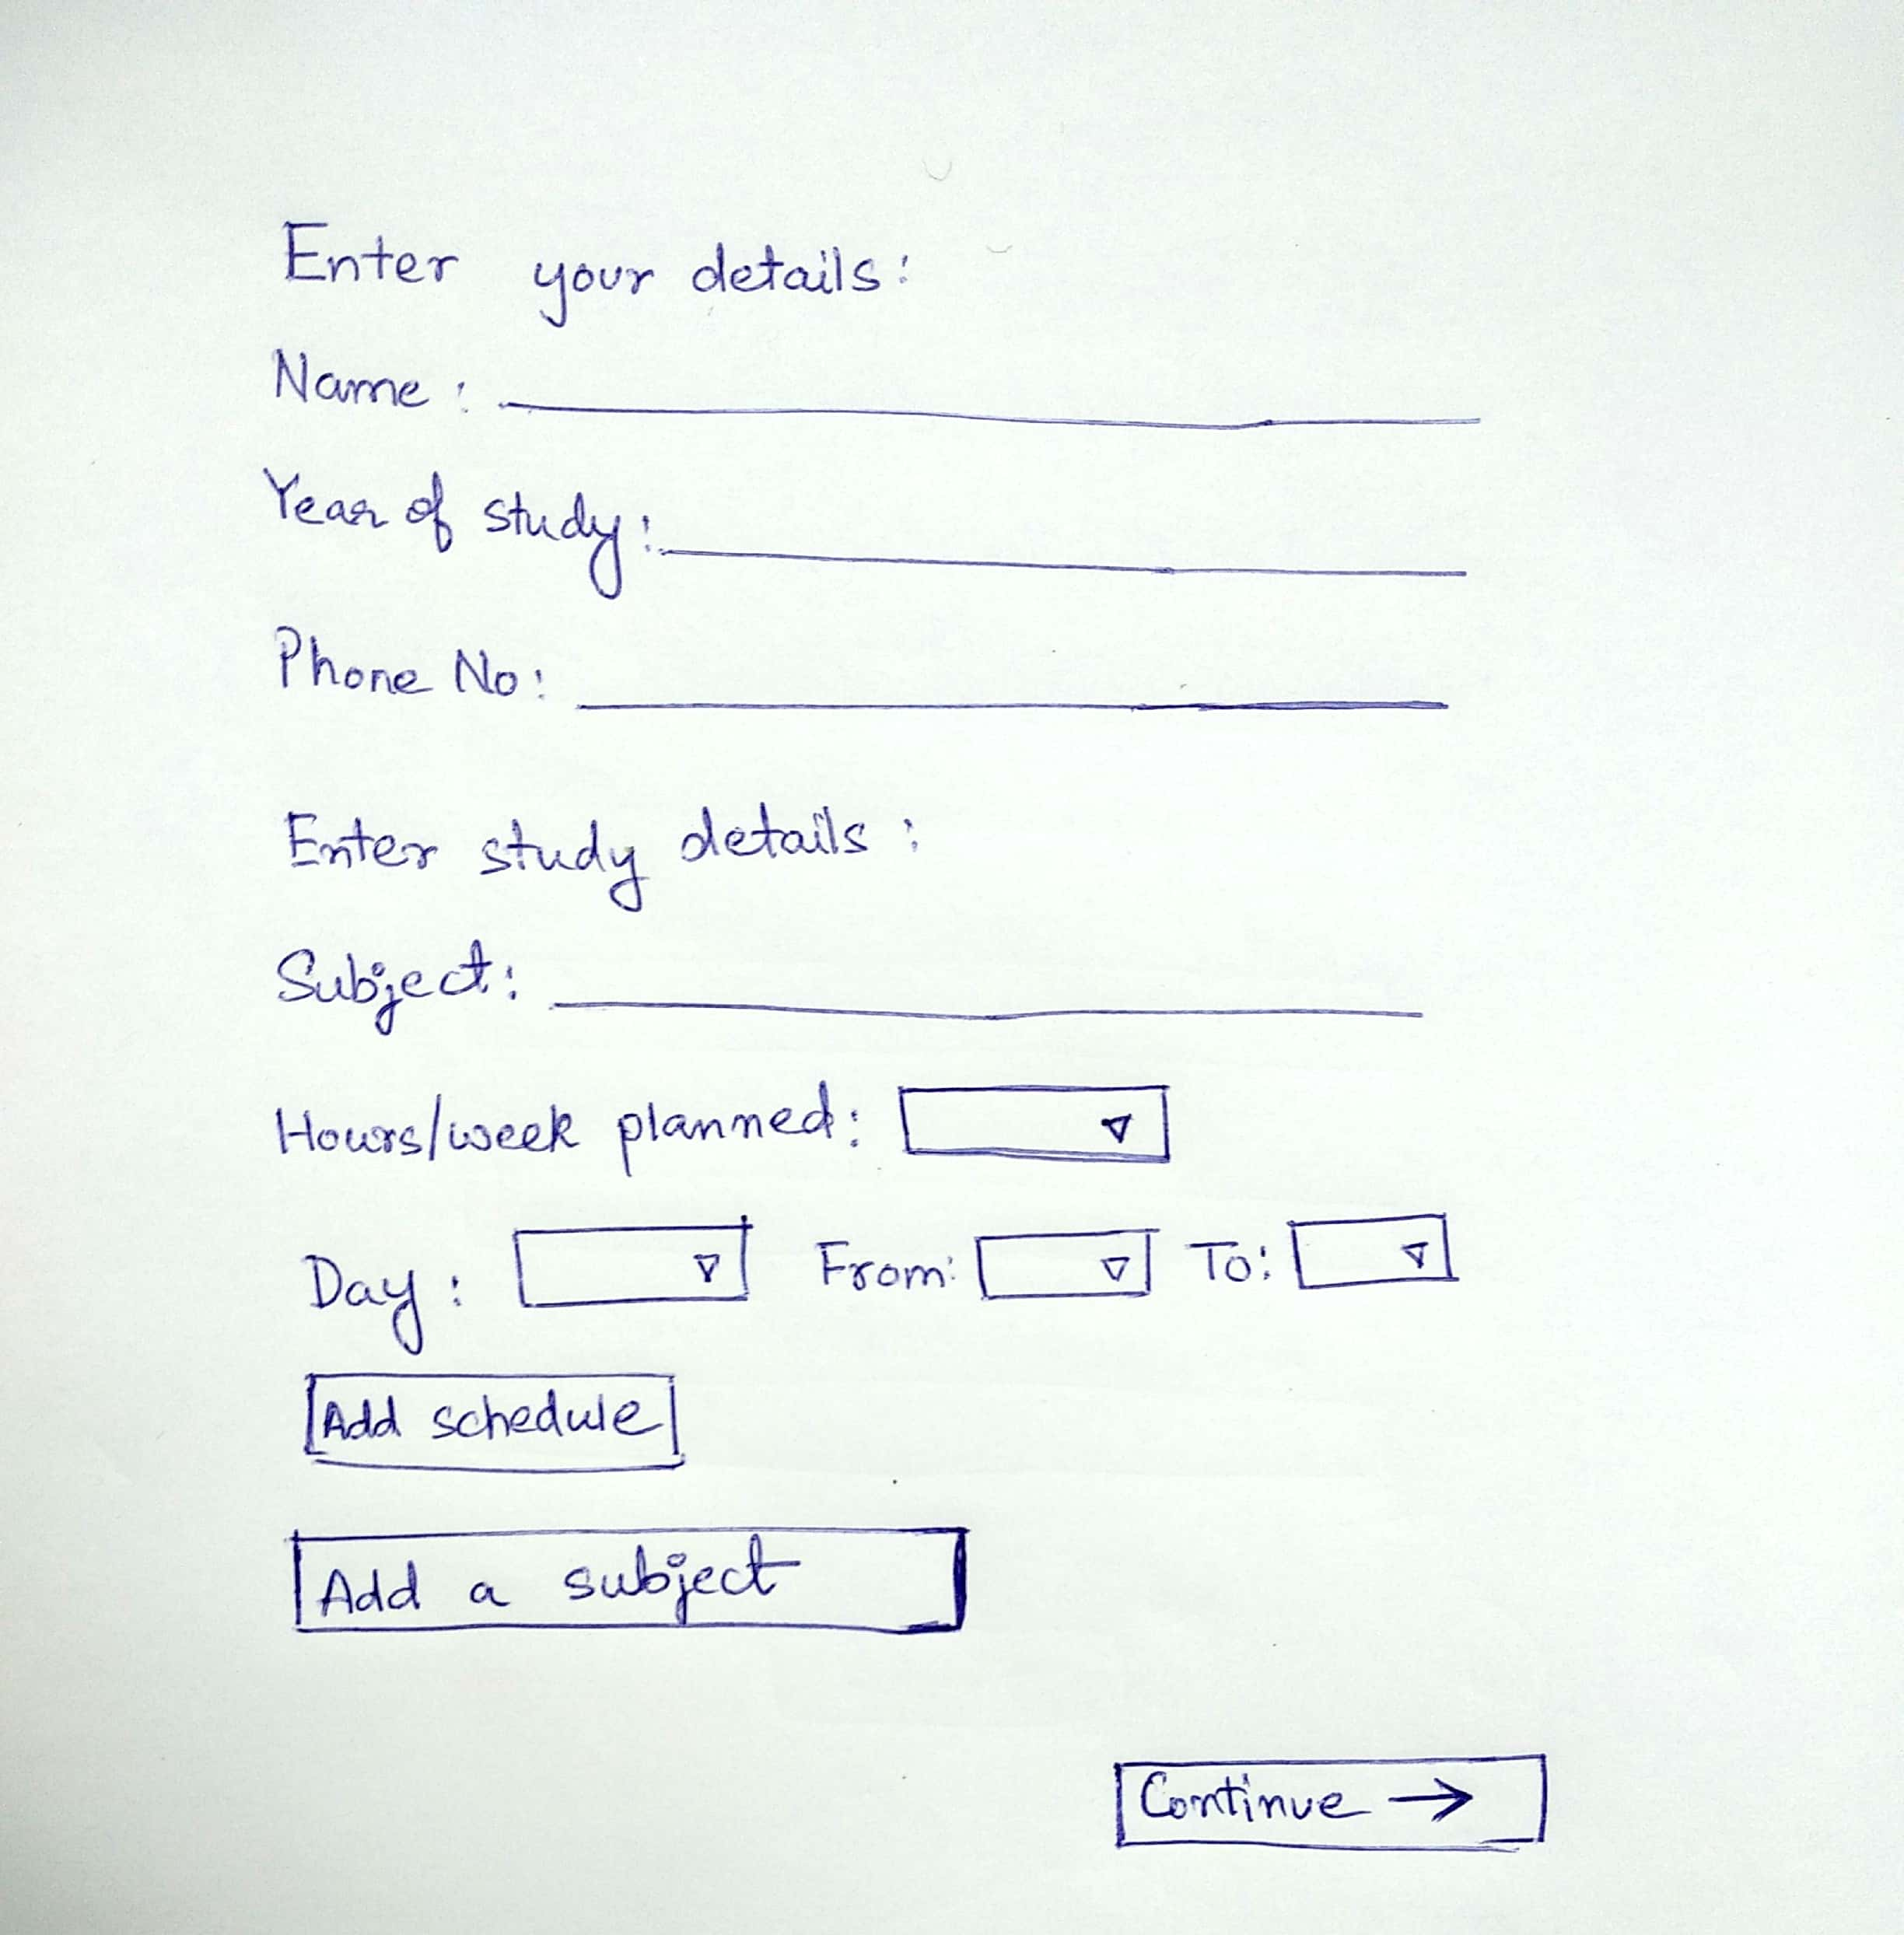

### Feature: Verify Study Tracker Setup

As a user of Study Tracker  
So that I can start tracking my schedule and goals  
I want verify my study goals and schedules

### 

### Feature: Dashboard of Study Tracker

As a user of Study Tracker  
So that I can manage my study goals  
I want to view my study schedules and current completion status

